ASSIGNMENT-1

**SMART HOME AUTOMATION USING SENSOR**

Team ID: PNT2022TMID38668

Team member name: Hemasri B A

Register no: 420419205005

Assigned on: 12.09.2022

Uploaded on: 16.09.2022

Circuit View:

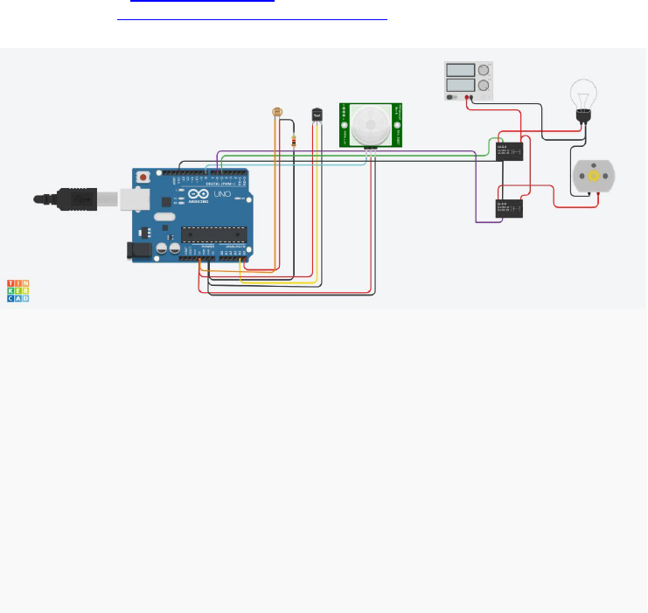

Component:

PIR Sensor

Arduino Uno R3

Temperature Sensor

DC Motor

Source code:

 Float x, y, z, temp;

Void setup()

{

pinMode(8, INPUT);

pinMode(5, OUTPUT);

pinMode(6, OUTPUT);

pinMode(A5, INPUT);

pinMode(A4, INPUT);

Serial.begin(9600);

}

Void loop()

{

X=digitalRead(8);

Y=analogRead(A5);

Z=analogRead(A4);

Serial.println(x);

Serial.println(y);

Serial.println(z);

temp = (double)z/1024;

temp = temp*5;

temp = temp-0.5;

temp = temp*100;

if ((x>0))

{

If ((y<550)&&(temp>30))

{

digitalWrite(5, HIGH);

digitalWrite(6, HIGH);

}

else

if((y<550)&&(temp<30))

{

digitalWrite(5, HIGH);

digitalWrite(6, LOW);

}

Else if((y>550)&&(temp>30))

{

digitalWrite(5, LOW);

digitalWrite(6, HIGH);

}

else if ((y>550)&&(temp<30))

{

digitalWrite(5, LOW);

digitalWrite(6,LOW);

}

}

else

{

digitalWrite(5, LOW);

digitalWrite(6, LOW);

}

}